Procedure/Assumptions/Directions:

1.The main output of the project is the file called “main_submission” which is a xlsx file of the required predicted data.
2 .ipynb file generated from MLJAR will be linked in the drive folder .You will need JupyterLabs or MLJAR studio app on your device to view the .ipynb files.
3.There is also a file which has the data comparison of the calculated v/s the predicted data through the ML model,named”comparison bte actual v/s predicted”.It is present in both xlsx and google sheet format due to errors in loading.
4. I couldn’t figure out the HIT ratio so instead I calculated the returns for long straddles instead.
5. The files were submitted in CSV UTF-8 format into the ML machine,but due to error in display of the data in google sheets I have converted the data back to xlsx format.
Data collection:
I calculated the PnL,the returns(long) and short,premiums of call and put options within the S&P500 excel sheet provided.
For PnL:
Premium received for the straddle(i.e. Premium for Call + Premium for Put) - |Strike - Spot|
For the Margin requirements:
The margin requirements for a short straddle/strangle is the greater of the two sides' short uncovered margin requirement plus the premium of the other leg.
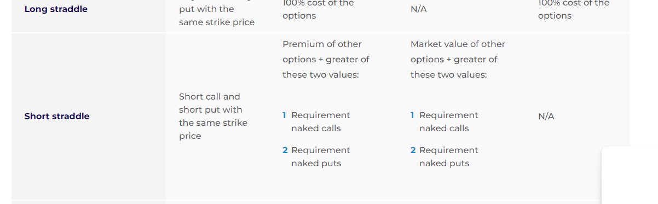
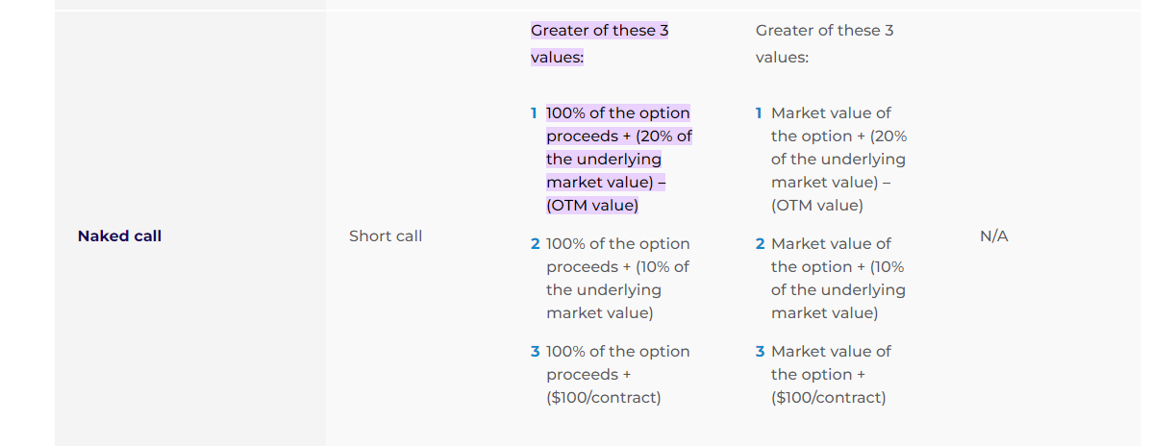
According to this we can calculate the margin required for pnl calculations and sharpe calculations:
Excel formula to calculate sharpe ratio: for s&p_main.csv file
=(AD2/(0.2*X2-Y2+AA2))
Implementation of the XGBoost classifier and other ensembles using MLJAR:
I copied and saved data for every 3 years to train AutoML,for eg:
In The training phase I supplied the csv file of 2014-2016,to train the ML algo,then to get output data I input the csv file 2017 only to get the predicted values for that year.
Eg:
Step 1: import the libraries

Step 2:Load the csv file of data from 2014-2016, here named test3a.csv.
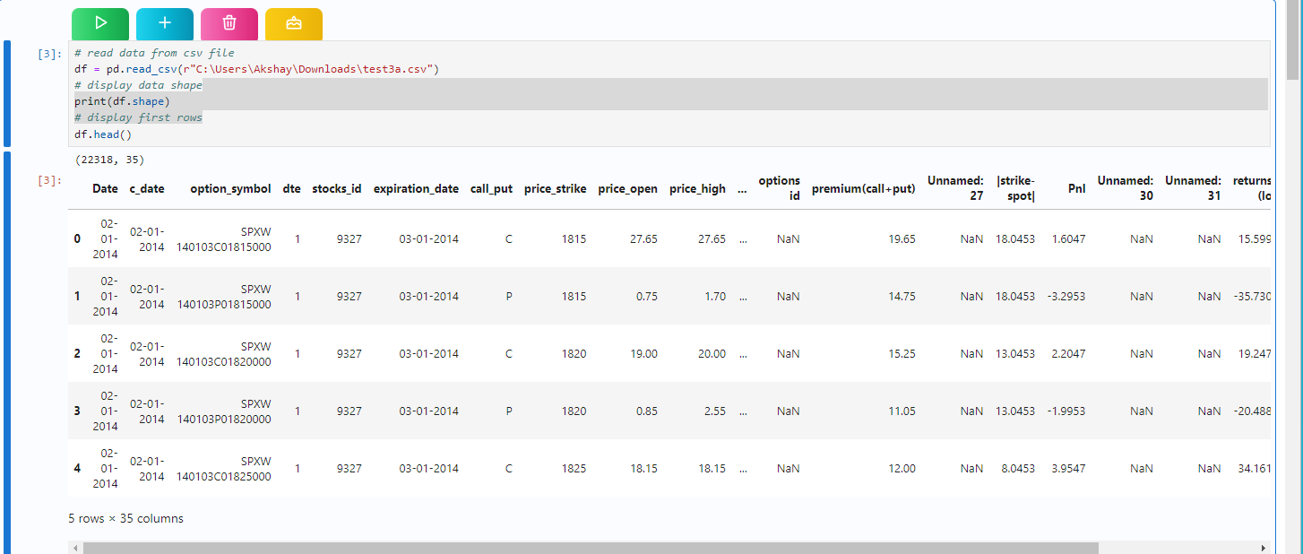
Step3:Data Wrangling , here we select our target variable and the input variables.
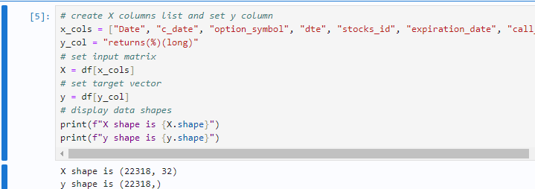
Step4:Train auto ML, here we decide the time limit for the training procedure which automatically classifies the various algorithms to use according to the time limit.I used 500 seconds initially and then moved to 700-1100 seconds for larger datasets to include AutoML steps: ['adjust_validation', 'simple_algorithms', 'default_algorithms', 'not_so_random', 'mix_encoding', 'golden_features', 'kmeans_features', 'insert_random_feature', 'features_selection', 'hill_climbing_1', 'hill_climbing_2', 'boost_on_errors', 'ensemble', 'stack', 'ensemble_stacked']
Step 5:submit a test data set here we submit a csv file of the year we are trying to predict to avoid errors involving index numbers in excel.
Step6:Predict with auto ML using the inbuilt feature.
Step 7:Submit another test csv file to let the AutoMl program know about the valid format for csv file generation.
Step8: We repeat this procedure for all three, long returns, short returns, Sharpe ratio.
Step 9: Now I created a dynamic_main file which was a copy of the s&p500 excel sheet in the problem statement, but as I got predicted data for each year through ML generation , I updated this copy file so that each consecutive result relies on the previous result.
Assumptions/precautions:
1.Some data could not be generated via MLJAR properly and had excess errors,so I copied some data directly from the main sheet to get relieable predictions of consecutive data sheets due to time limitations.Eg: straddle returns columns for 2020,straddle and sharpe columns for 2018.
2.When you use submission step in MLJAR , if the index of test3b file > test3a file then on running:
Submission[“Target”]=predictions;
It will throw an error, to fix this input file test3a instead.

